# Experiment 02

## Name: Prajyot Shinde Roll no: 57

Aim: To Build Your Application using AWS CodeBuild and Deploy on S3 / SEBS using AWS CodePipeline, deploy Sample Application on EC2 instance using AWS CodeDeploy.

## Step-1: Beanstalk Deployment

1. Login to your AWS account and search for Elastic Beanstalk in the search box

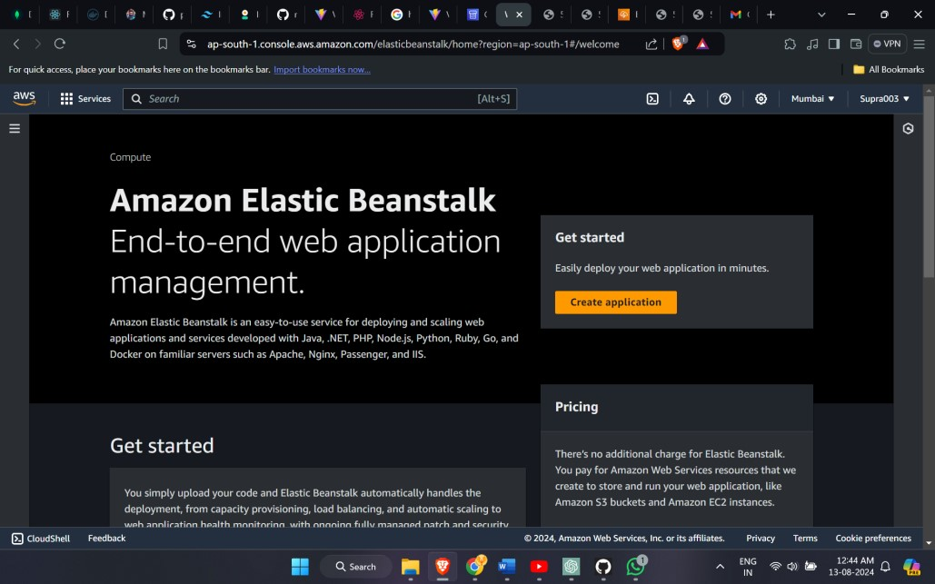

1. Open up Elastic Beanstalk and name your web app.

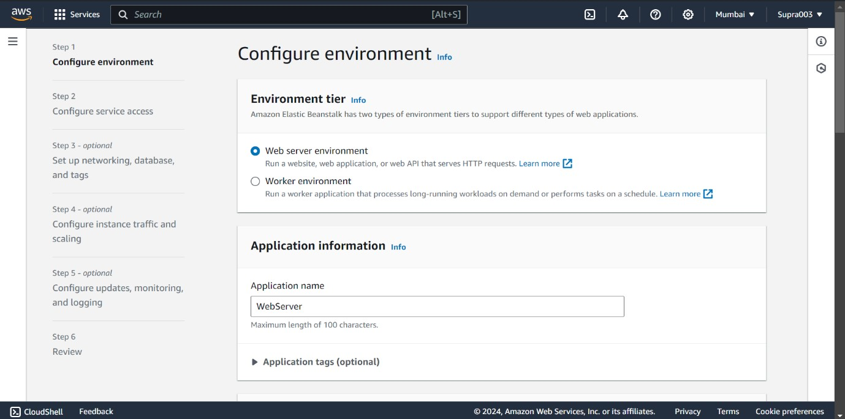

1. Choose Python from the drop-down menu and then click Create Application.

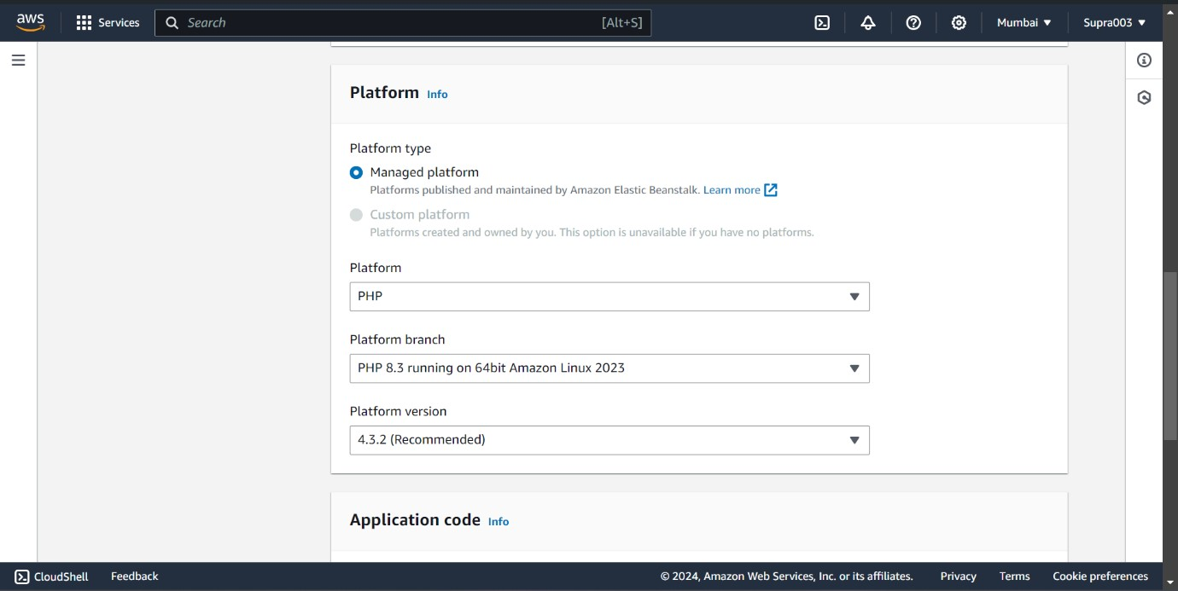

1. Choose the proper options

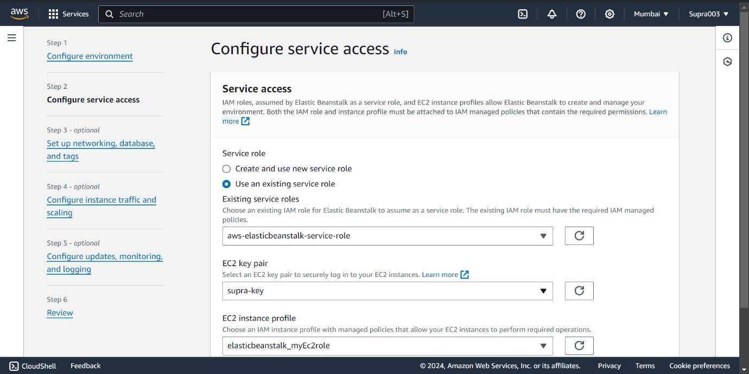

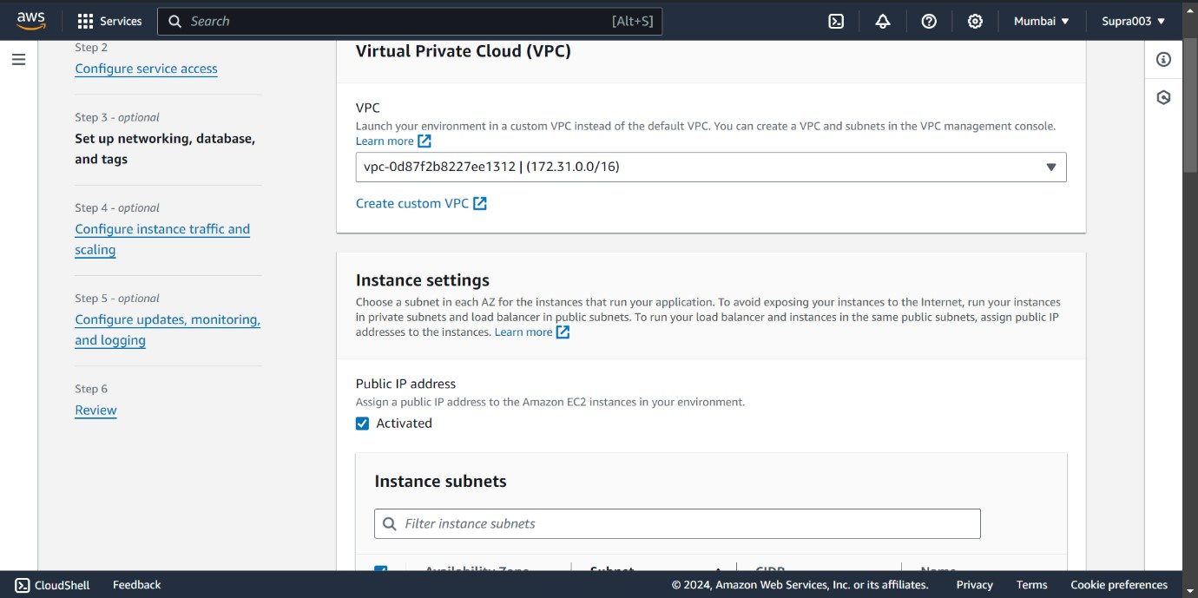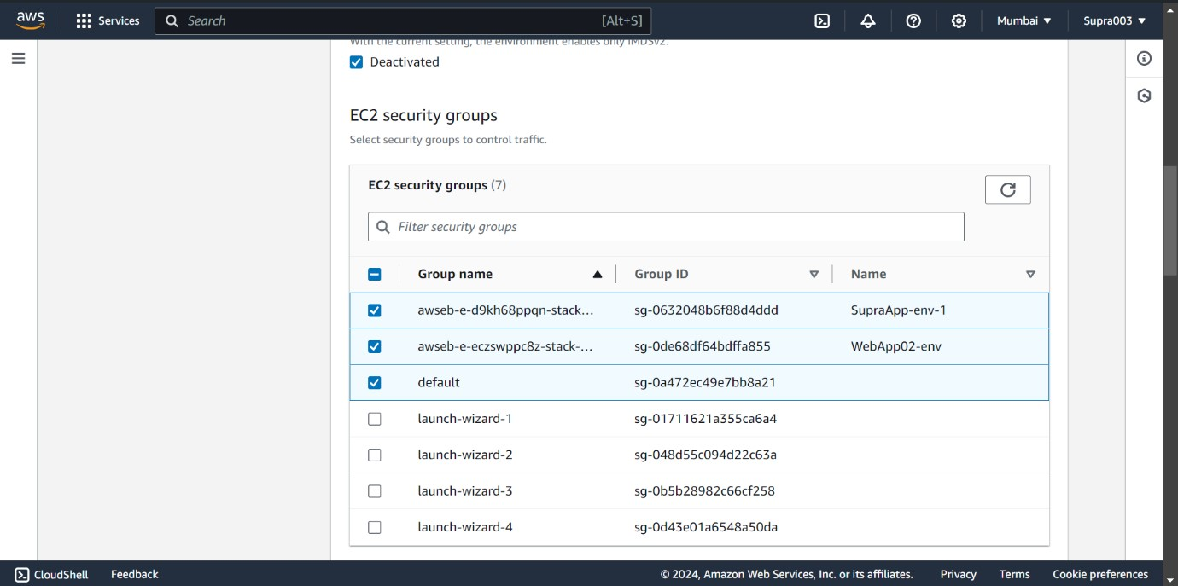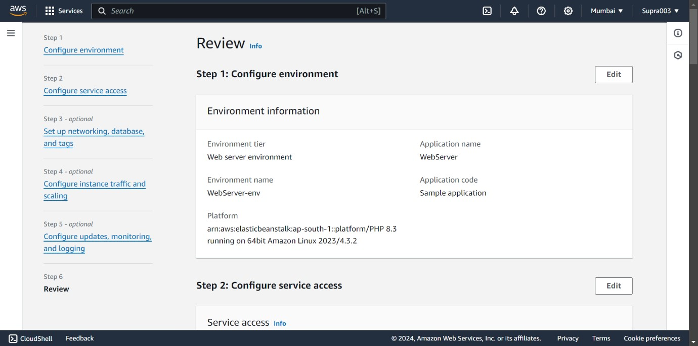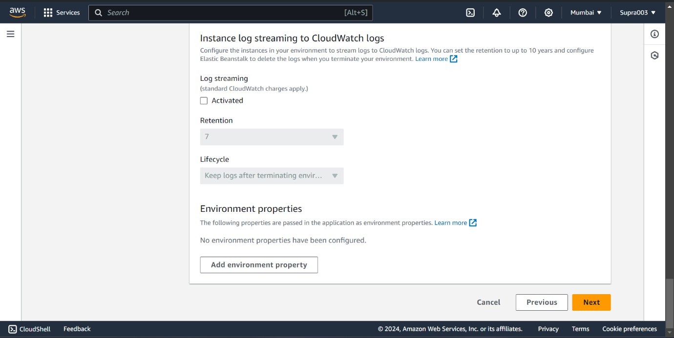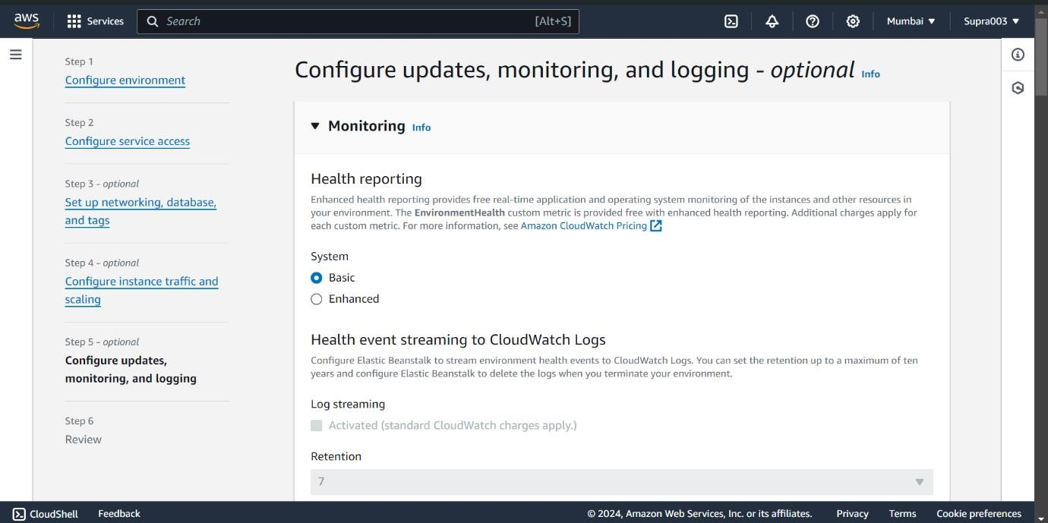

## Step-2: Creating CodePipeline

Beanstalk creates a sample environment for you to deploy your application. By default, it creates an EC2 instance, a security group, an Auto Scaling group, an Amazon S3 Bucket, Amazon CloudWatch alarms and a domain name for your Application.

Create a CodePipeline and give pipeline name

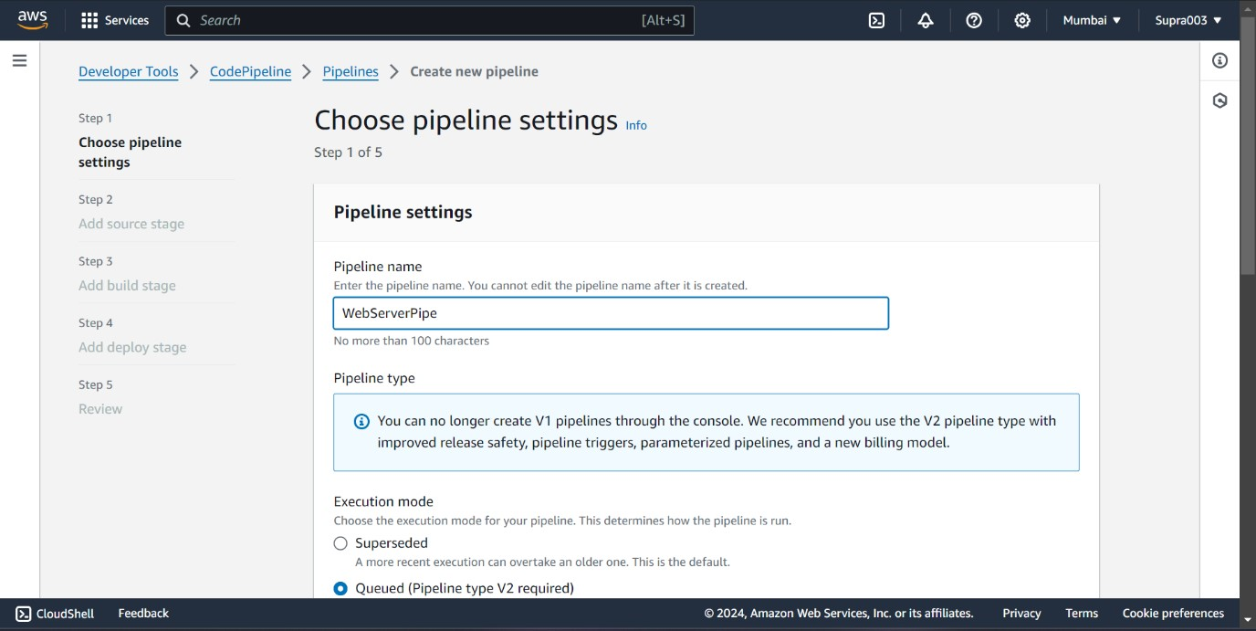

Create a Github connection

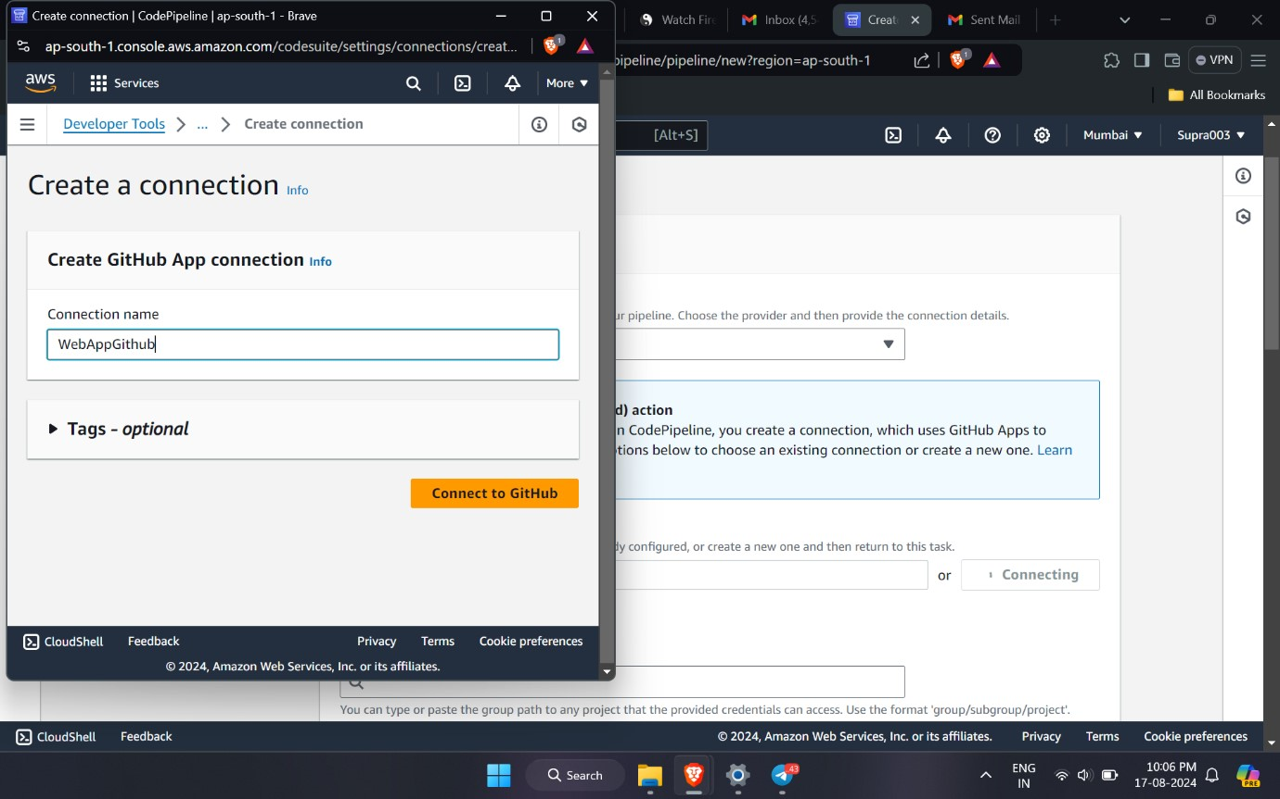

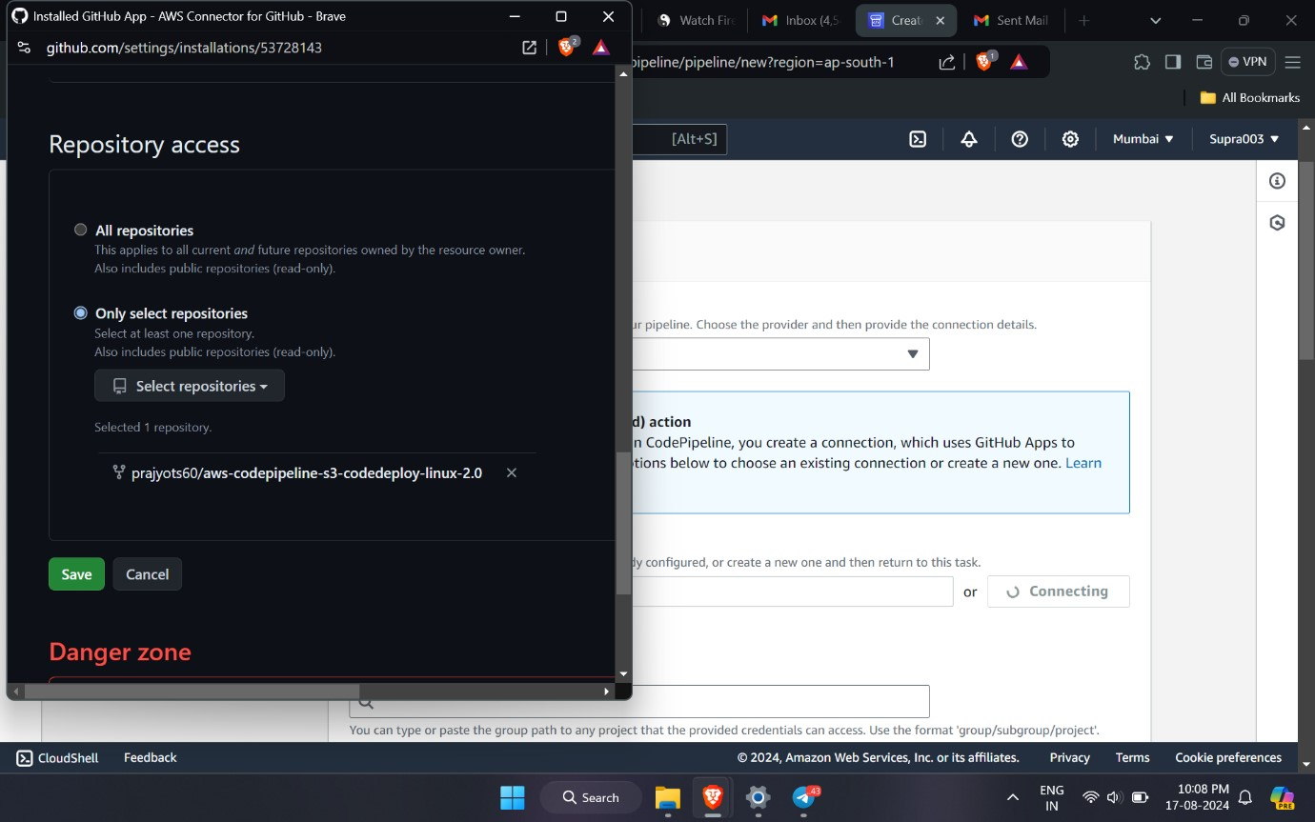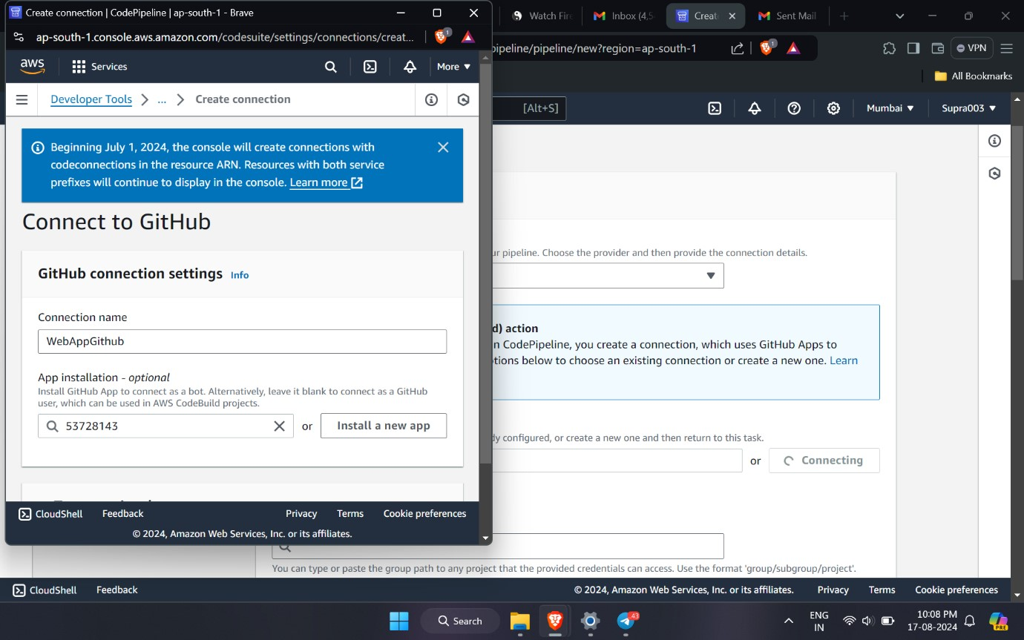

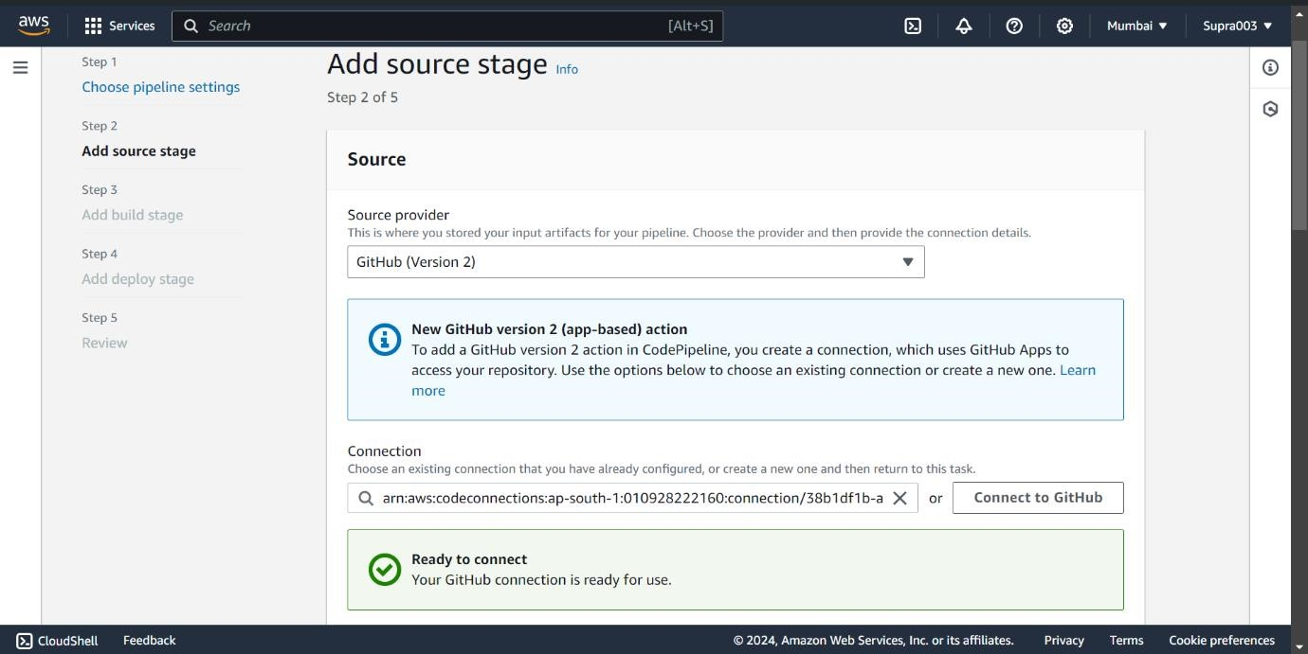

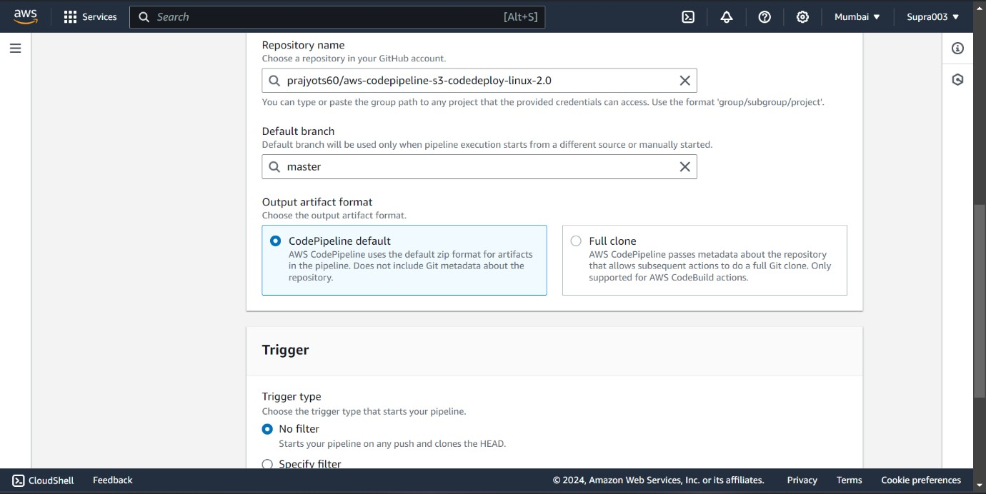

## For deploy choose elastic beanstalk

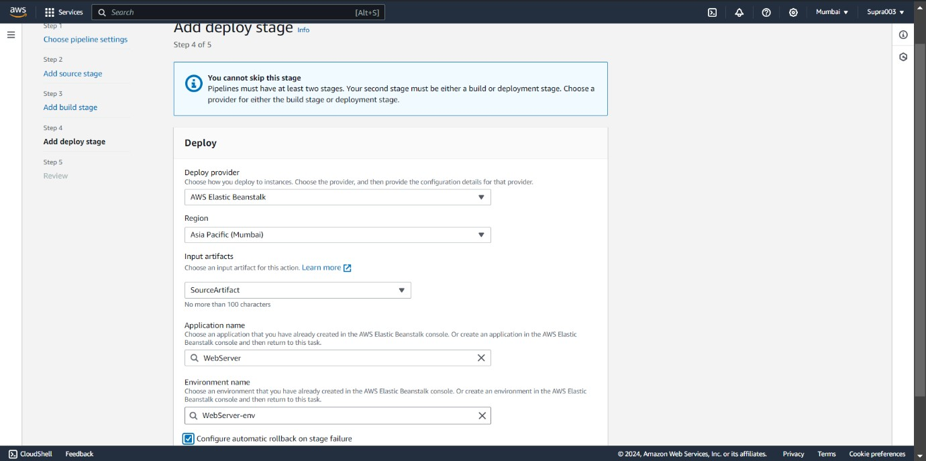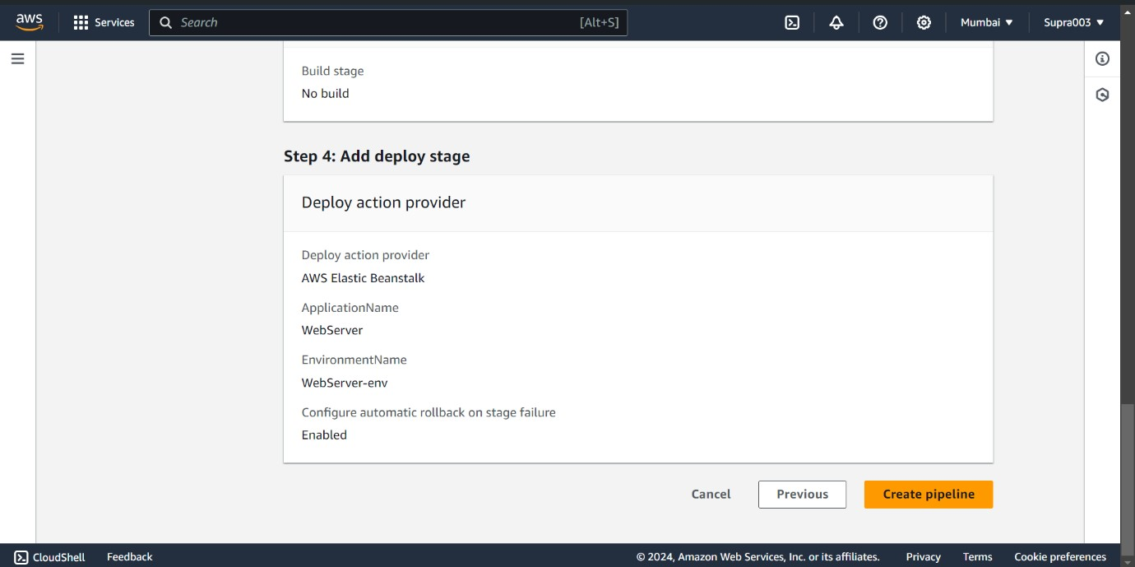

Make connection between code pipeline and beanstalk. And Green means successfully connected.

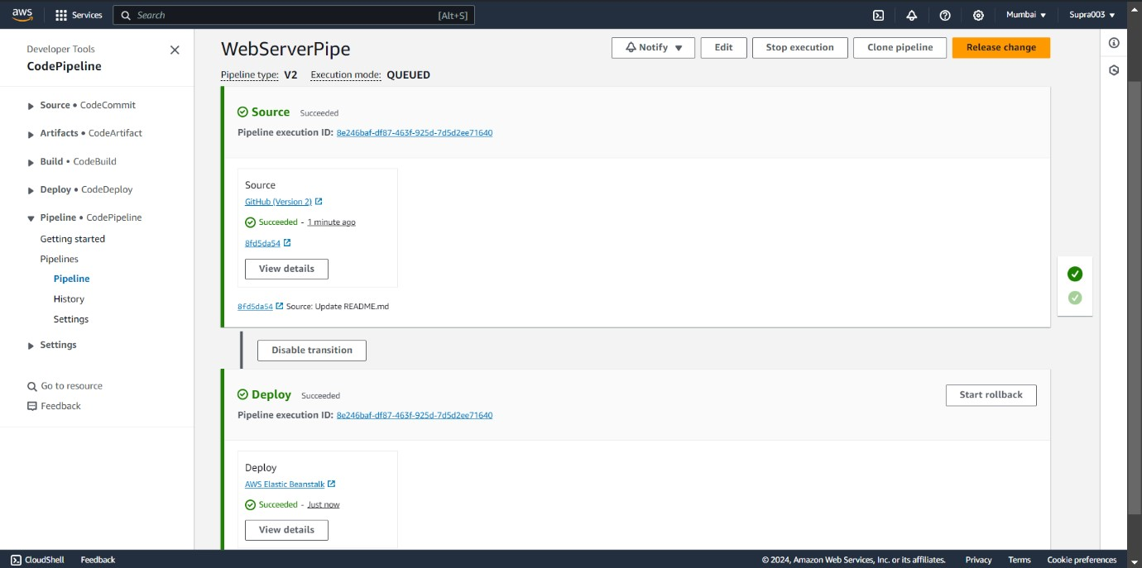

Click on domain to view you hosting site

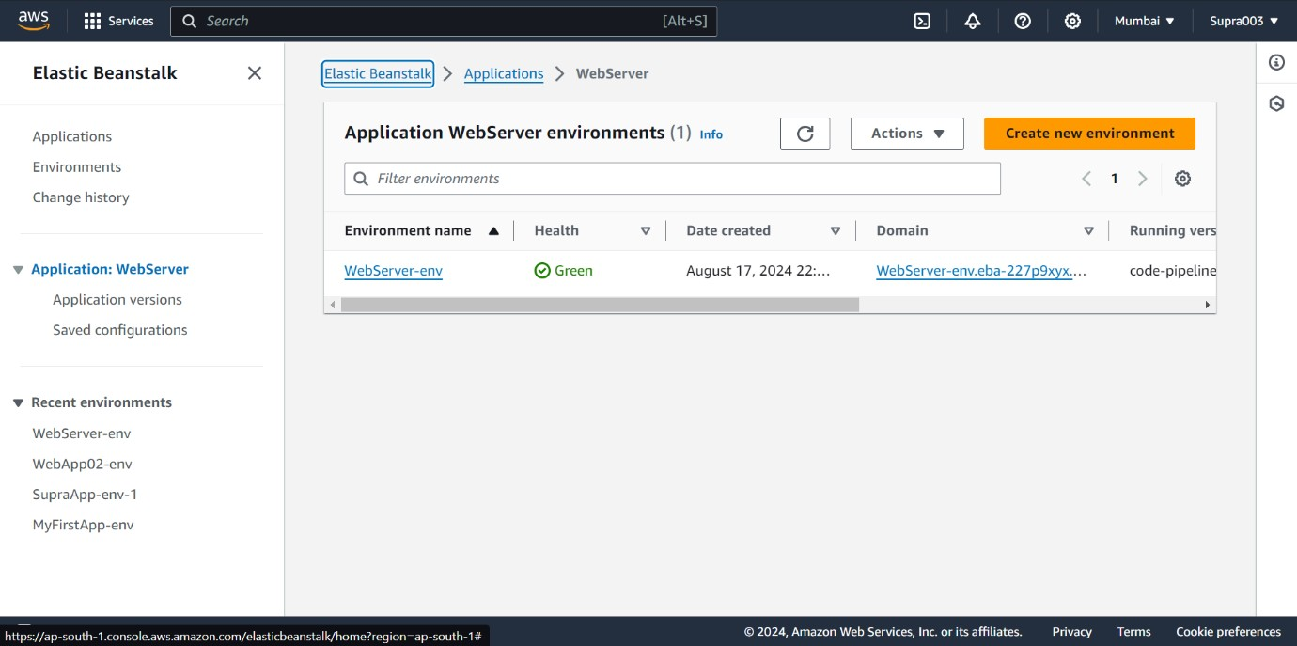

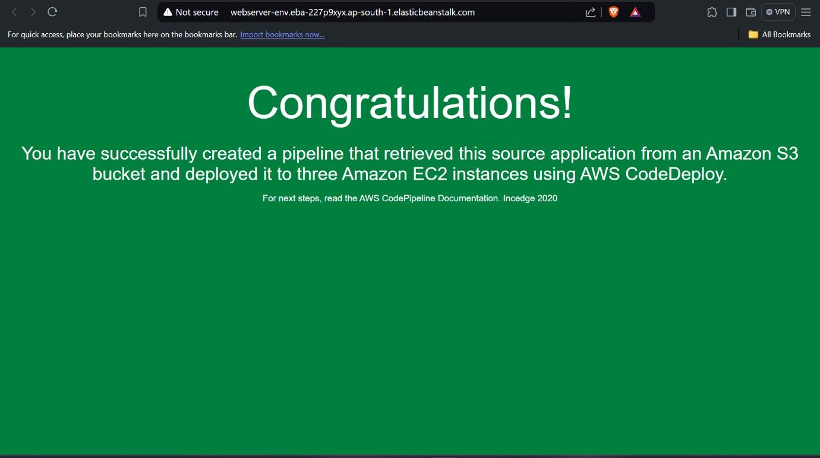

**Hosting a static website on Amazon S3**

